***Objective* -:** (i) To plot and visualize the electric field lines and equipotential surfaces.

(ii) To determine the variables that affect the strength and direction of the electric field for a static arrangement of charges.

(iii) To investigate the variables that affect the strength of the electrostatic potential (voltage).

(iv) Describe and draw models for common static electricity concepts (transfer of charge, induction, attraction, repulsion, and grounding).

***Theory*** **-:** **Electric field** is the region around a charged particle within which another charged particle will experience an electric force.

**Electrostatic Potential** in the region of the electric field, at any point, is defined as the work done in bringing a unit charge from infinity to that point such that the particle undergoes no acceleration. Now, as we know, the [potential energy](https://byjus.com/physics/potential-energy/) of a charged particle at infinity is assumed to be zero, so the electrostatic potential of an object is calculated for a particle with reference to infinity.

An ***electric field line*** is an imaginary line or curve drawn through a region of empty space so that its tangent at any point is in the direction of the electric field vector at that point. The relative closeness of the lines at some place gives an idea about the intensity of electric field at that point. Electric field lines have the following properties -:

* Electric field lines always begin on a positive charge and end on a negative charge, so they do not form closed curves. They do not start or stop in mid-space.
* The number of electric field lines leaving a positive charge or entering a negative charge is proportional to the magnitude of the charge.
* Electric field lines never intersect.
* In a uniform electric field, the field lines are straight, parallel and uniformly spaced.
* The electric field lines can never form closed loops, as line can never start and end on the same charge.
* These field lines always flow from higher potential to lower potential.
* If the electric field in a given region of space is zero, electric field lines do not exist.
* The tangent to a line at any point gives the direction of the electric field at the point. Also, this is the path on which a positive test charge will tend to move if free to do so.

Any surface over which the potential is constant is called an **equipotential surface**. In other words, the potential difference between any two points on an equipotential surface is zero. An equipotential surface has the following properties-:

* Work done in moving a charge over an equipotential surface is zero.
* The electric field is always perpendicular to an equipotential surface.
* The spacing between equipotential surfaces enables us to identify regions of strong and weak fields.
* Two equipotential surfaces can never intersect. If two equipotential surfaces could intersect, then at the point of intersection there would be two values of electric potential which is not possible.

**Static electricity** is an imbalance of electric charges within or on the surface of a material. The charge remains until it is able to move away by means of an electric current or electrical discharge. Static electricity is named in contrast with current electricity, which flows through wires or other conductors and transmits energy.

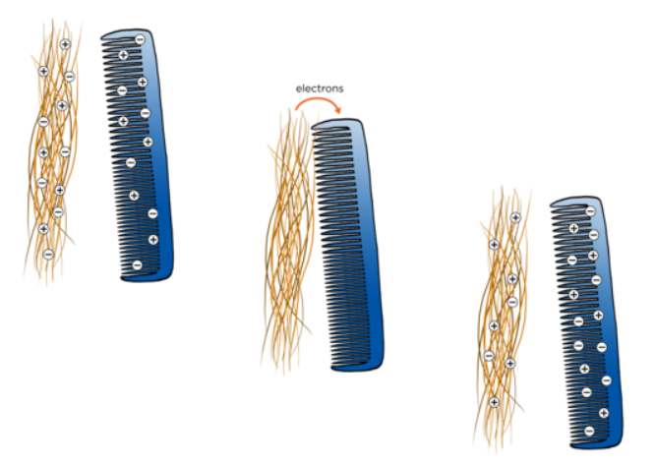Materials are made of atoms that are normally electrically neutral because they contain equal numbers of positive charges and negative charges. The phenomenon of static electricity requires a separation of positive and negative charges. When two materials are in contact, electrons may move from one material to the other, which leaves an excess of positive charge on one material, and an equal negative charge on the other. When the materials are separated, they retain this charge imbalance.

For example, when you rub a comb through your hair, some electrons from your hair jump over to the comb. This makes the comb negatively charged and the hair to be positively charged.

**Charging by Conduction -:** Charging by conduction involves the contact of a charged object to a neutral object. Hence when an uncharged conductor is brought in contact with a charged conductor, charge is shared between the two conductors and hence the uncharged conductor gets charged. During charging by conduction, both objects acquire the same type of charge and these charges are retained after these objects are separated.

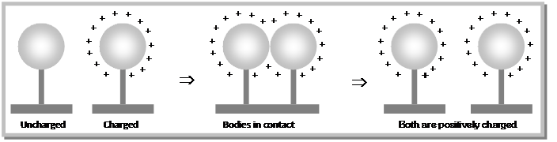

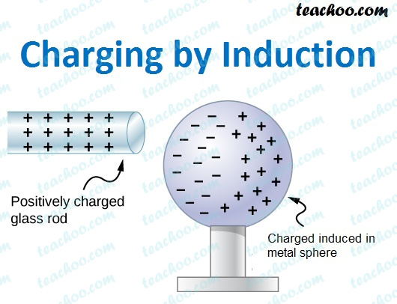**Charging by Induction -:** In this process, a charged object is brought near but not touched to a neutral conducting object. The presence of a charged object near a neutral conductor will induce (force) electrons within the conductor to move.    
The movement of electrons leaves an imbalance of charge on opposite sides of the neutral conductor. While the overall object is neutral (i.e., has the same number of electrons as protons), there is an excess of positive charge on one side of the object and an excess of negative charge on the opposite side of the object. The object stays neutral when this charged object is taken far away again and no charge redistribution takes place.

***Observations -:***

***Objective(i)***

Plot the electrical field lines and equipotential surfaces by estimation for

1. Single positive charge (+1 Q),

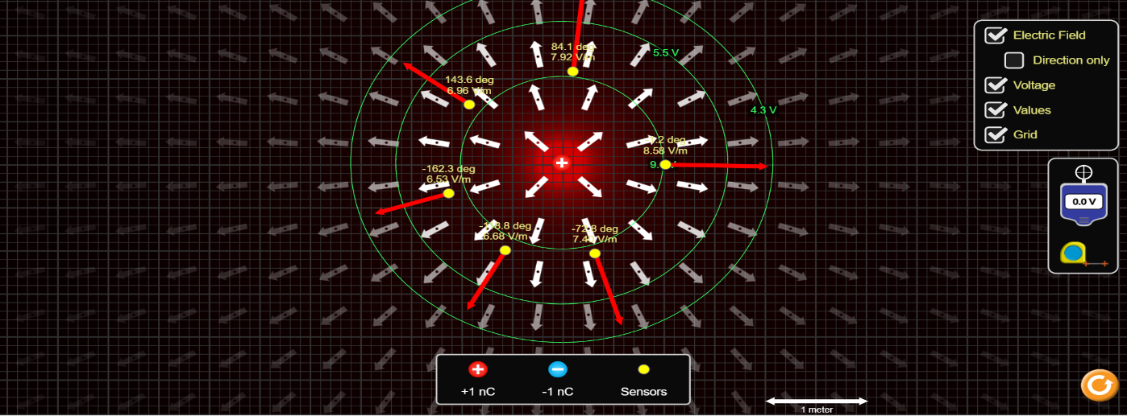

1. Single negative charge (-2 Q),

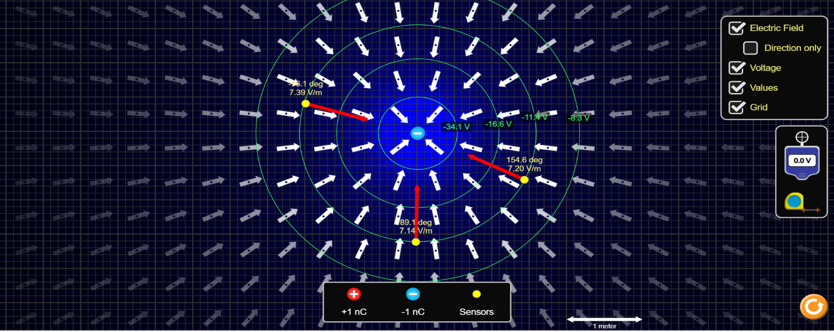

1. 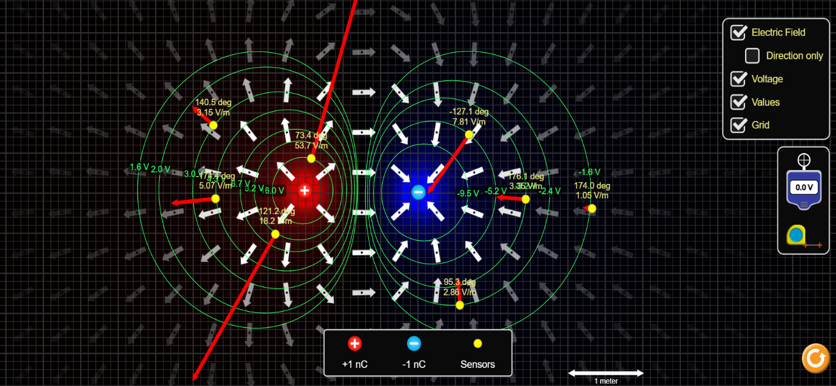Single dipole (one positive charge and one negative charge)
2. One charge with +2Q and one charge with –Q

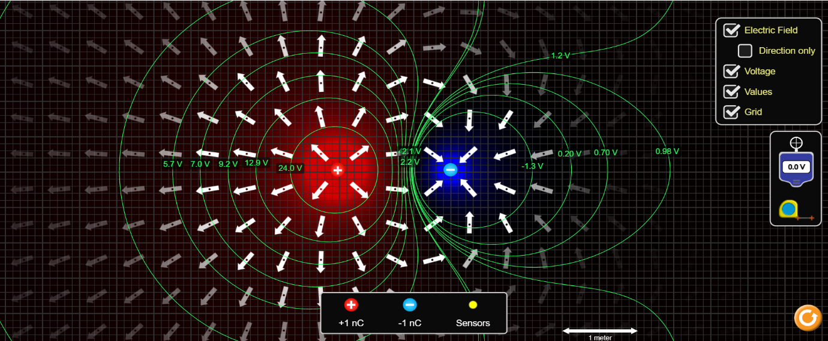

1. 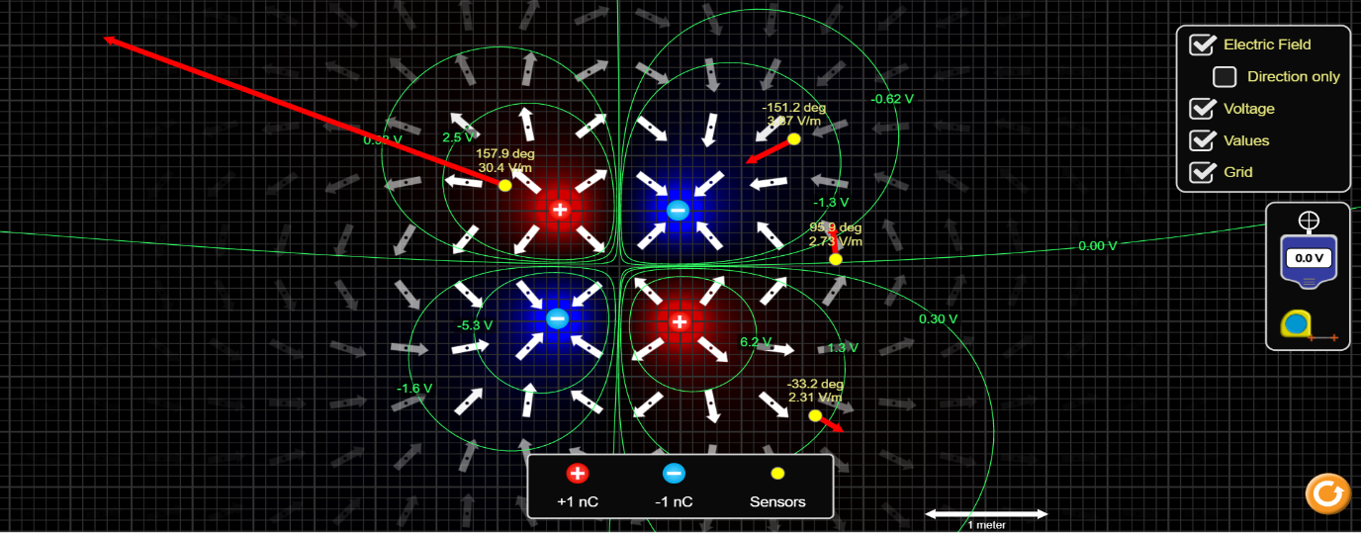Quadrupole arrangement
2. Octupole arrangement

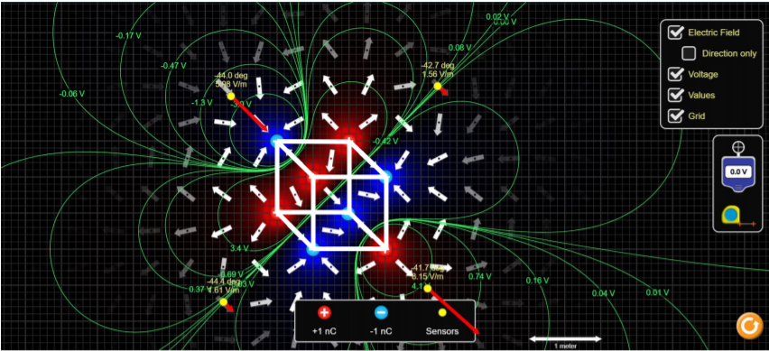

***Objective(ii)***

Determine the variables that affect the strength and direction of the electric field for a static arrangement of charges.

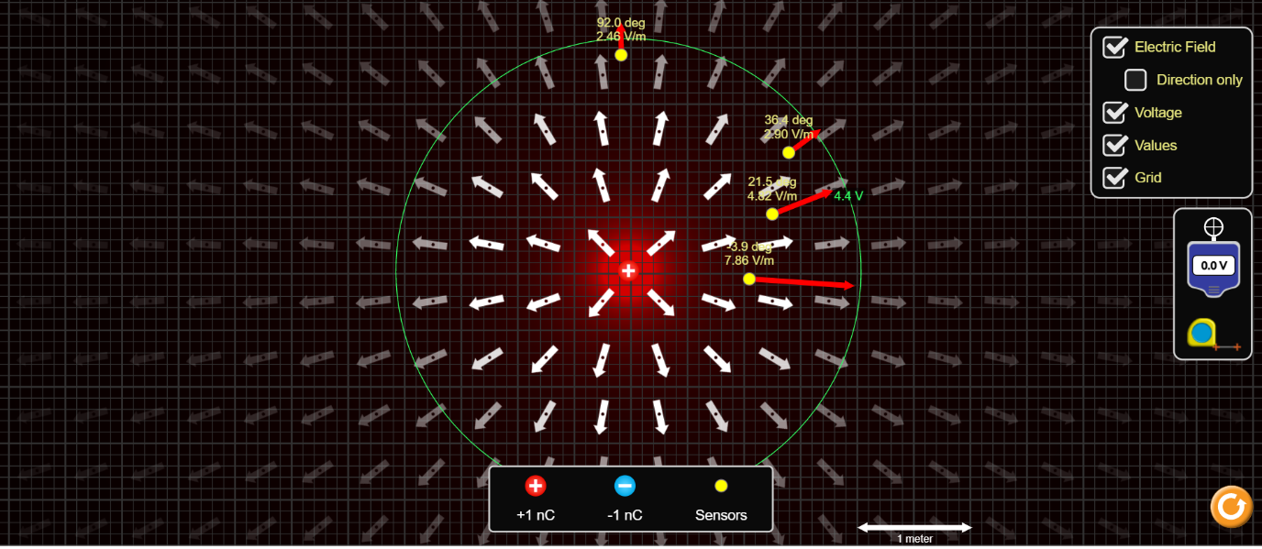

For measuring the strength of electric field, we have used the feature of sensors provided in the simulator. The sensors indicate the strength of field in V/m at that point in space. For better results, keep the following points in mind:

* It is preferable to keep the sensor on right side of charge for better use of distance measuring tool provided.
* Always measure the distances with reference to the center of charge.
* Since V=0 and r=0 at the center of source charge,

dV/dr = (V-0)/(r-0)

= V/r

**NOTE:** All measurements have been done with reference to the point where Potential is zero, so the above formula is valid for all calculations

**Observation Tables** -:

* Single positive charge (+1 Q),

|  |  |  |  |
| --- | --- | --- | --- |
| S.No. | Potential  (in V) | Distance  (in cm) | Strength(dV/dr)  (in V/m) |
| 1. | 5.250 | 171.6 | 3.06 |
| 2. | 7.160 | 125.0 | 5.73 |
| 3. | 10.057 | 89.2 | 11.30 |

* Single negative charge (-2 Q),

|  |  |  |  |
| --- | --- | --- | --- |
| S.No. | Potential  (in V) | Distance  (in cm) | Strength(dV/dr)  (in V/m) |
| 1. | -8.730 | 206.9 | -4.22 |
| 2. | -11.360 | 157.9 | -7.20 |
| 3. | -14.050 | 122.2 | -11.5 |

* Single dipole (one positive charge and one negative charge)

|  |  |  |  |
| --- | --- | --- | --- |
| S.No. | Potential  (in V) | Distance  (in cm) | Strength  (in V/m) |
| 1. | -21.140 | 488.1 | -4.33 |
| 2. | 8.690 | 110.3 | 7.88 |
| 3. | 9.430 | 82.0 | 11.55 |

* One charge with +2Q and one charge with –Q

|  |  |  |  |
| --- | --- | --- | --- |
| S.No. | Potential  (in V) | Distance  (in cm) | Strength  (in V/m) |
| 1. | -6.030 | 100.0 | -29.4 |
| 2. | 0.031 | 149.7 | 4.4 |
| 3. | 1.190 | 200.1 | 1.13 |

* Quadrupole arrangement

|  |  |  |  |
| --- | --- | --- | --- |
| S.No. | Potential  (in V) | Distance  (in cm) | Strength  (in V/m) |
| 1. | -0.07 | 100.0 | -20.8 |
| 2. | -0.04 | 149.7 | 4.48 |
| 3. | -0.02 | 199.4 | 1.18 |

1. Octupole arrangement

|  |  |  |  |
| --- | --- | --- | --- |
| S.No. | Potential  (in V) | Distance  (in cm) | Strength  (in V/m) |
| 1. | -9.76 | 115.2 | 39.7 |
| 2. | -1.79 | 175.3 | 5.28 |
| 3. | -0.59 | 224.9 | 1.43 |

***Objective(iii)***

Investigate the variables that affect the strength of the electrostatic potential (voltage).

To check the above mentioned, we take a charge and fix its position. Then we introduce a test charge and analyze electrostatic potential. Charge 1 is the source charge here.

**Observation 1:**

Keeping the nature and magnitude of both charges fixed and varying the distance between them.

|  |  |  |  |  |
| --- | --- | --- | --- | --- |
| S.No. | Charge 1  (in C) | Charge 2  (in C) | Distance between charges (in cm) | Electrostatic Potential(V) |
| 1. | +q | -q | 50.4 | 5.824 |
| 2. | +q | -q | 100.1 | 10.550 |
| 3. | +q | -q | 150.5 | 12.920 |

**Observation 2:**

Keeping the distance between both charges fixed and varying the nature and magnitude of charges.

|  |  |  |  |  |
| --- | --- | --- | --- | --- |
| S.No. | Charge 1  (in C) | Charge 2  (in C) | Distance between charges (in cm) | Electrostatic Potential(V) |
| 1. | +q | -q | 200.2 | 6.982 |
| 2. | +q | +q | 200.2 | 18.45 |
| 3. | -q | -q | 200.2 | -18.46 |

***Objective(iv)***

Initially the charges on the T-shirt, balloon and the wall are equally distributed.

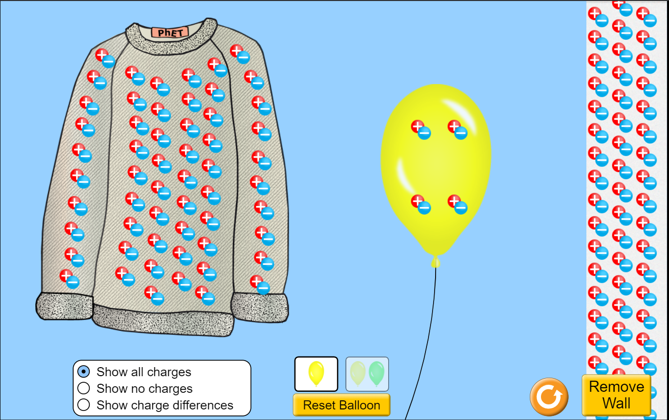

* **Transfer of Charge** -: When the balloon is rubbed on the T-shirt, it acquires some electrons from the T-shirt. This happens because on rubbing the balloon on the T-shirt, heat is generated due to friction and some electrons on the T-shirt acquire enough energy to overcome the atomic attractions and they get transferred to balloon. Hence, the balloon becomes negatively charged and the T-shirt becomes positively charged.

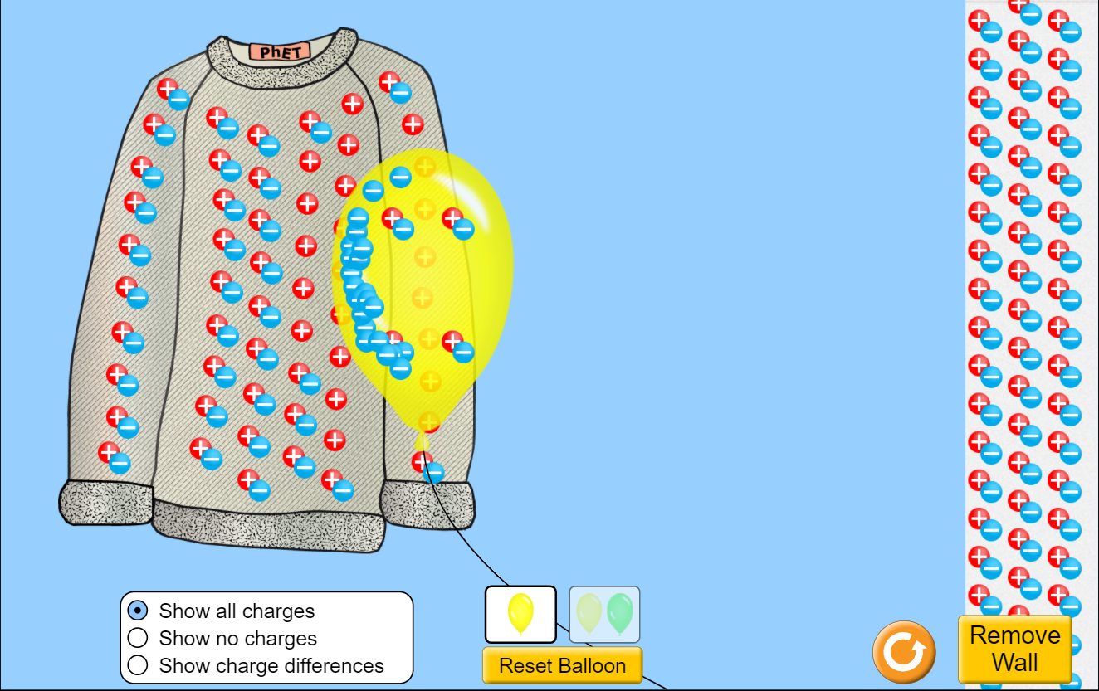

* **Induction** -: As the balloon is now negatively charged, on bringing it near the wall (that has balanced charges), the electrons at the wall move away from the balloon. This phenomenon is known as induction.

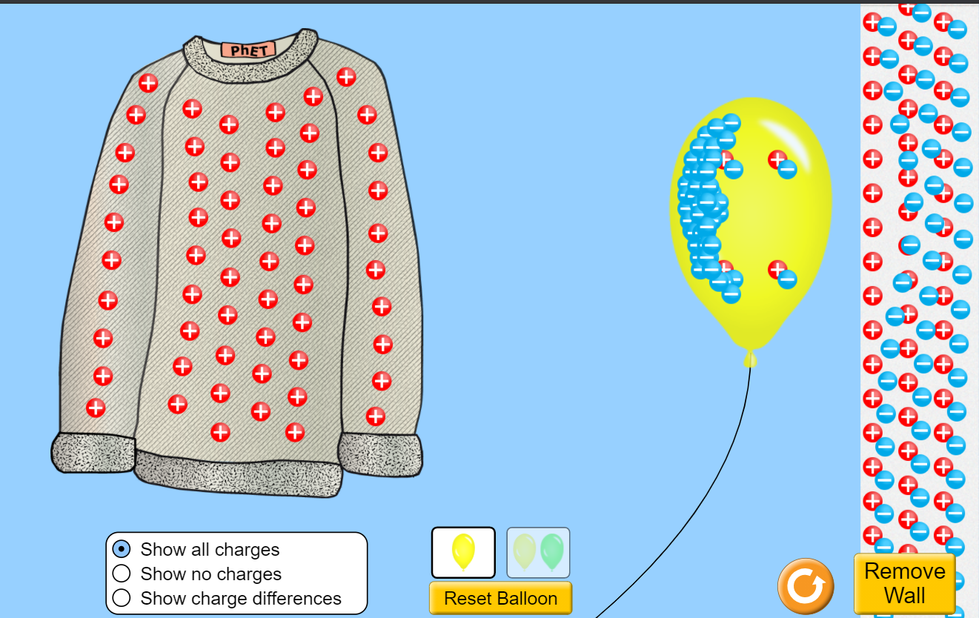

* **Attraction** -: As after rubbing the balloon on the T-shirt, the balloon became negatively charged and the T-shirt became positively charged. On shifting this charged balloon, away from the T-shirt, the balloon went back towards the T-shirt as they both had different static charges on them.

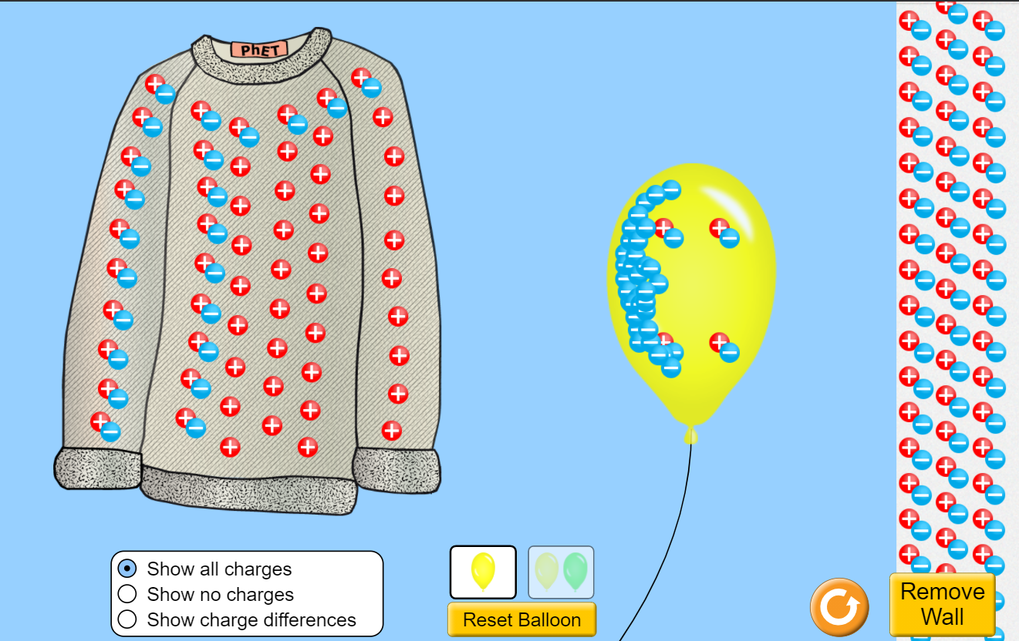

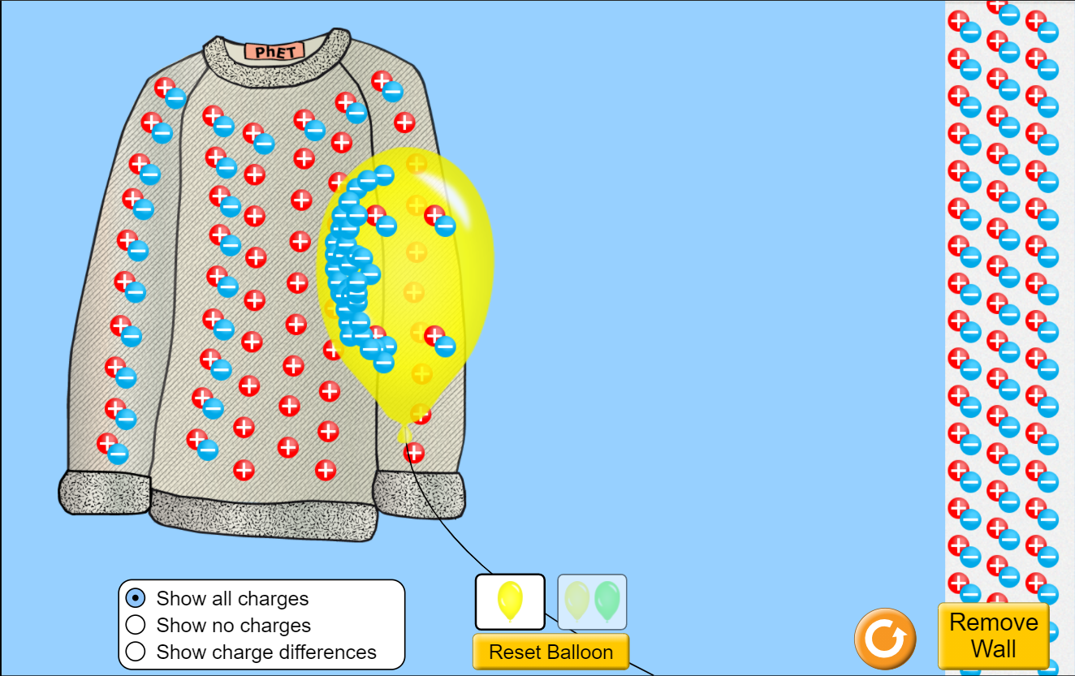

* **Repulsion** -: Now, if we rub two different balloons on the T-shirt, both will acquire negative charge and the T-shirt will become positively charged. Both the balloons will be attracted towards the T-shirt (or one may be attracted towards the T-shirt and one towards the wall) but the two balloons will repel each other.

Balloons are charged negatively

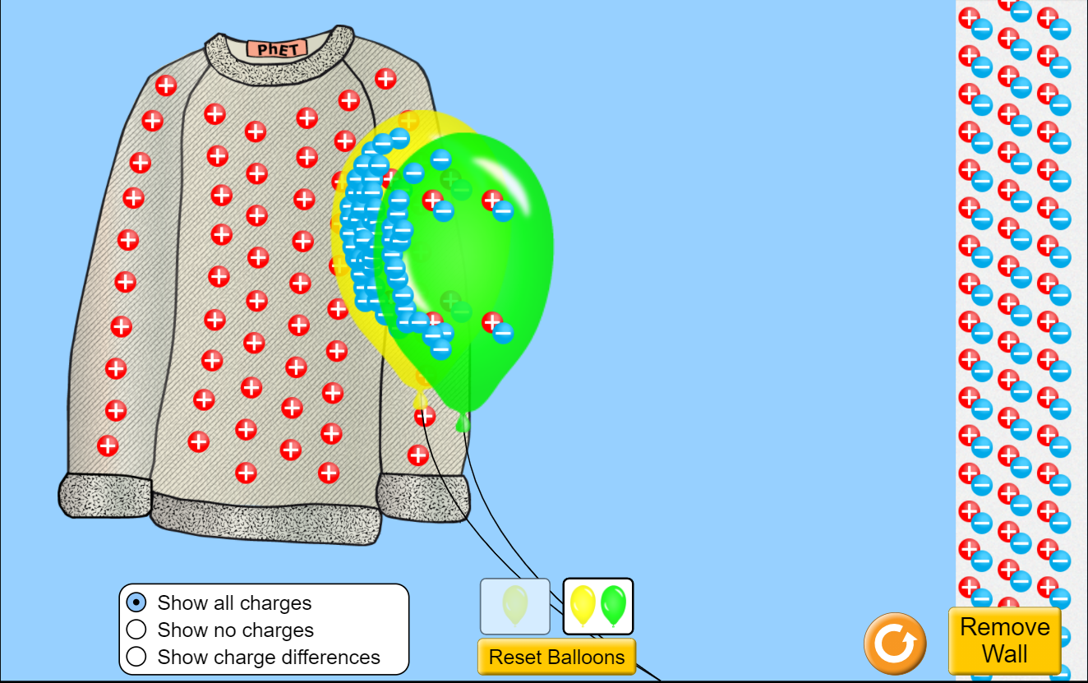

Balloons repel each other but both are attracted towards T-shirt

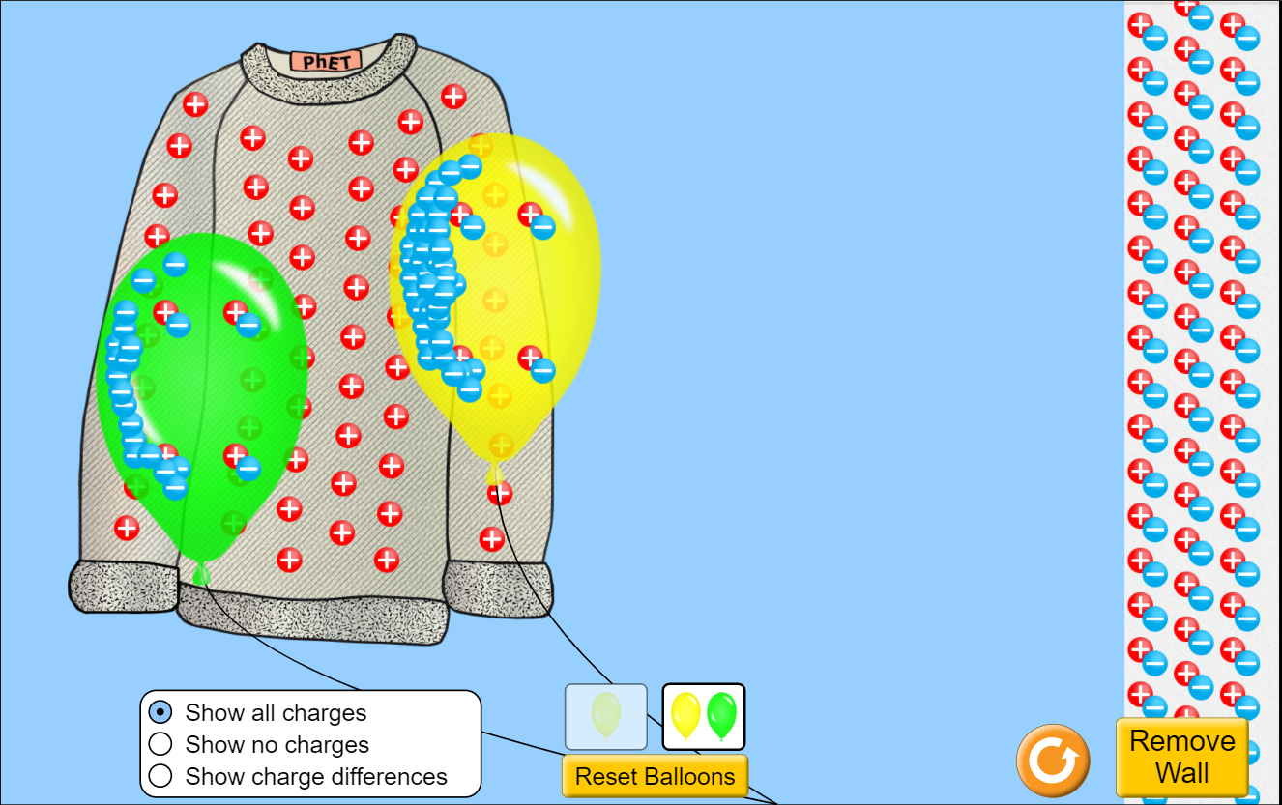

Balloons repel each other and one is attracted towards T-shirt while the other is attracted towards the wall

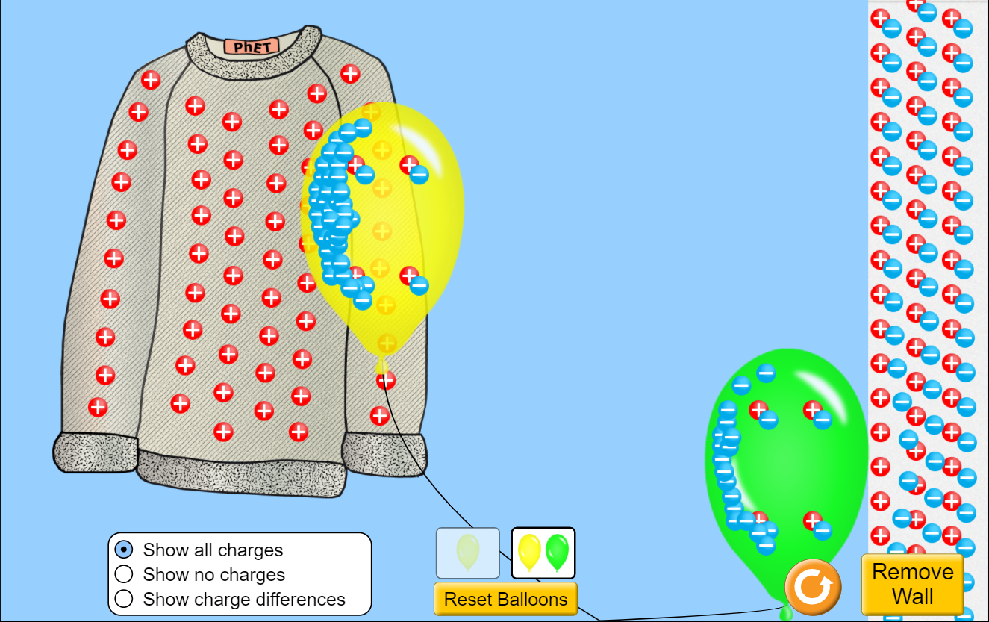

* **Grounding** -: On keeping a charged balloon to the wall for some duration, the charge developed over the balloon gets transferred to Earth by the concept of grounding.

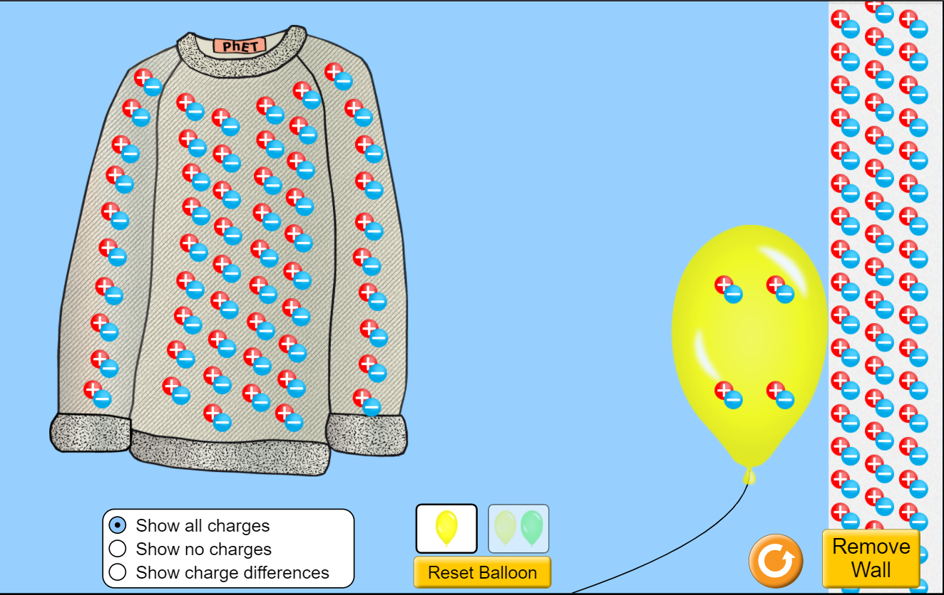

***Error analysis -:*** We know that octupole is cubic arrangement. Cube is a 3D-Figure and we have plotted it in 2D-Figure, thus discrepancies might occur and results may not match with actual results. Also, the errors here are due to simulation algorithms and cannot be minimized by us. Had these been perfumed in Lab, there must have been instrumental errors etc. leading to discrepencies and we would have measured those errors.

***conclusions -:***

***Objective(i)***

Plotting the electric field lines and equipotential surfaces on the simulator led us to draw the following conclusions -:

About Electric Field Lines

* Electric field lines always begin on a positive charge and end on a negative charge, so they do not form closed curves.
* The number of electric field lines leaving a positive charge or entering a negative charge is proportional to the magnitude of the charge.
* Electric field lines never intersect.
* In a uniform electric field, the field lines are straight, parallel and uniformly spaced.
* These field lines always flow from higher potential to lower potential.
* If the electric field in a given region of space is zero, electric field lines do not exist.
* The tangent to a line at any point gives the direction of the electric field at the point. Also, this is the path on which a positive test charge will tend to move if free to do so.

About Equipotential Surfaces

* Work done in moving a charge over an equipotential surface is zero.
* The electric field is always perpendicular to an equipotential surface.
* The spacing between equipotential surfaces enables us to identify regions of strong and weak fields.
* Two equipotential surfaces can never intersect. If two equipotential surfaces could intersect, then at the point of intersection there would be two values of electric potential which is not possible.

***Objective(ii)***

From the above observation tables it is clear that the strength of electric field at a point majorly depends on three factors:

* the net charge
* the distance from the charge
* the direction of strength of field depends on the sign of net charge (negative or positive)

***Objective(iii)***

* the electrostatic potential(V) is a scalar quantity
* it depends on the magnitude of charge
* it depends on the distance between the charge and the point
* it also depends on the nature of charge

***Objective(iv)***

* Charges from one object can be transferred to another object by means of rubbing two objects together. During rubbing, frictional heat provides the electron enough energy to transfer themselves from one object to other. Only the electron can be transferred and not the positive charge as it is heavier and present at the centre of an atom. After the transfer, the object which receives electrons become negatively charged while the object which loses electrons become positively charged.
* If two objects have similar kind of charges, they repel each other and if two objects have different kind of charges, they attract each other.
* If a charged object is brought near to a neutral object, opposite kind of charges are induced on the surface of the neutral object. An important point here is, the charged object remains charged and the neutral object remains neutral. No transfer of charge takes place, only the charge redistributes itself.